Technical Architecture Document - 8c8afc339

User:
You are a highly experienced Enterprise Workflow Architect and Principal Engineer. Write a deeply detailed technical architecture document (NOT PR/FAQ) for the following product idea.
Product Context:
We are designing an IDE-like Workflow Development Platform that allows businesses to:
Onboard SOPs → Parse into structured flows
Generate LLM prompt with agents/services mapping
Visualize workflows interactively
Configure parameters and auto-prepopulate where possible
Convert into workflow execution format (e.g., YAML, JSON, BPMN)
Test nodes and flows (mock/lower environment validation)
Promote to production with versioning and rollback
The document will be used by technology and architecture teams — focus on lifecycle, components, technology selection, and architecture layers.
Deliverables the LLM must produce:
1. Lifecycle Flow Documentation
End-to-end workflow lifecycle process (SOP → Visualization → Config → Conversion → Test → Promote → Version Management).
Visual lifecycle flow diagram (image format, not text).
2. Architecture Overview
Layered architecture:
Presentation/UI layer (Workflow Designer, SOP Onboarding UI)
Processing/Logic layer (SOP parser, prompt generator, parameter handler, validator)
Execution & Orchestration layer (workflow engine, LangGraph runtime, agents)
Data & Registry layer (workflow registry, param DB, versioning repository)
Integration & Security layer (auth, audit, environment manager)
Provide a high-level architecture diagram (image).
3. Technology Choices Table
For each component (parser, visualization, workflow execution, data store, auth, testing, monitoring), create a Buy vs Build recommendation table with options.
Compare traditional Workflow Engines vs LangGraph workflow.
4. Workflow Engine Path
Create an architecture section dedicated to workflow engine-based design (Camunda, Temporal, Airflow, AWS Step Functions).
Provide a visual system diagram (image) showing components, integrations, and lifecycle.
Highlight pros and cons.
5. LangGraph Implementation Path
Create a parallel section dedicated to LangGraph-based design (agentic workflows).
Provide a visual system diagram (image) specific to LangGraph implementation.
Show how SOP → LLM Prompt → LangGraph nodes & edges → Execution.
Compare with workflow engine approach.
6. Comparison Section (Workflow Engine vs LangGraph)
Provide a detailed comparison table of both approaches across axes: scalability, flexibility, developer experience, observability, testing, versioning, extensibility, maturity.
Recommend when to use each based on business context.
7. Sample Outputs
Include:
Example visual workflow lifecycle diagram (end-to-end)
Example layering architecture diagram
Example system architecture diagram (workflow engine path)
Example system architecture diagram (LangGraph path)
Example technology decision matrix table
8. Constraints
⚠️ Do not generate code.
Provide clear, image-based diagrams where possible.
Provide tables for technology options, layering, and comparison.
Document should read as a reference architecture blueprint, not a PR memo.
Instruction for the LLM:
Produce a single, consolidated technical architecture document with:
End-to-end Workflow Management Lifecycle section with diagrams.
Layered System Architecture section with visual diagrams.
Technology Decision Tables (Buy vs Build, Engine vs LangGraph).
Separate Workflow Engine Path section (with diagram).
Separate LangGraph Implementation Path section (with diagram).
A Comparison section summarizing tradeoffs between the two models.
Style: professional, clear, with visual images + structured tables that can be shared with engineering and architecture teams.

Abacus AI ChatLLM:
Thought for 52 seconds
**Planning technical architecture document**
I need to create a detailed technical architecture document. It'll include lifecycle flow documentation with a visual diagram, an architecture overview featuring layered architecture and a high-level diagram, and a technology choices table for buy vs. build decisions. I'll also compare traditional workflow engines to LangGraph, with sections for both paths that include visuals. There are constraints like not generating code and providing clear diagrams and tables. I’ll use the functions.Image Generation tool for the necessary images while considering their aspect ratios.
**Creating diagram prompts**
I need to create at least four images for the technical architecture document. The instructions mention that images will display immediately, so I want to choose the aspect ratios wisely—16:9 seems good for horizontal diagrams. I'll craft clear prompts for the image generation tool. We also need to add tables for technology choices and comparisons in Markdown, avoiding any code blocks. The goal is to be detailed yet organized, including headings, bullet points, and necessary lifecycle details, without getting overly verbose.
**Detailing component recommendations**
I need to include Buy vs. Build recommendations for various components. Options will cover workflow solutions like Camunda, Temporal, and Step Functions, as well as parsers like spaCy combined with LLM or commercial document processing. Visualization tools can include React Flow, Mermaid, or Draw.io. For workflow execution, I’ll list Camunda 8, Temporal, and Airflow, while proposing data stores like Postgres and Redis. We also need authentication, testing strategies, and monitoring tools, along with a versioning repository using Git. I'll organize this in sections with formats like YAML, JSON, or BPMN for workflow execution.
**Outlining testing and deployment strategies**
I need to specify how to test various components, including using local sandboxes, stub connectors, and data contracts, along with unit and integration tests for nodes. There should also be simulation and dry-run capability and a test harness for LLM prompts with golden datasets. For deployment, I’ll include versioning, rollback, release management, and gating processes. I should map agents and services for LLM prompts, handle parameters with metadata inference, and visualize workflows interactively, using a React-based graph editor. Security concerns like RBAC and audit logs also need to be addressed, along with scaling options such as microservices or modular architecture.
**Preparing architecture document structure**
I need to create a "LLM prompt generator" and compare it with the "LangGraph runtime" for agentic flows while including a Technology Choices Table that designates "buy recommended" or "build recommended." I'll include a comparison section that rates options based on scalability, flexibility, and other factors, providing relative ratings and recommendations. Images are essential, so I plan to generate four key diagrams covering lifecycle flow and several architecture perspectives. The document structure will address each important aspect, including testing, promoting to production, and security layers, while keeping it concise and avoiding bloat. I’ll ensure to include necessary surrounding details as well, such as test nodes and comprehensive workflow formats. Now, let’s start by triggering the image generation for the lifecycle diagram and layered architecture!
**Creating architecture diagrams**
I need to show inter-layer arrows and external systems, including LLM providers, SaaS APIs, and databases, all presented in a clean, enterprise blueprint style. For the third prompt, I'll outline a Workflow Engine path system diagram, detailing components like the SOP Intake Service, Parser, Workflow Engine Cluster, and CI/CD pipeline, while highlighting the observability stack.
The fourth prompt will focus on the LangGraph implementation path, showcasing components like the SOP Intake, Graph Compiler, and Node types like ToolNode and LLMNode, with an emphasis on how everything connects. Let’s go ahead and create those images!
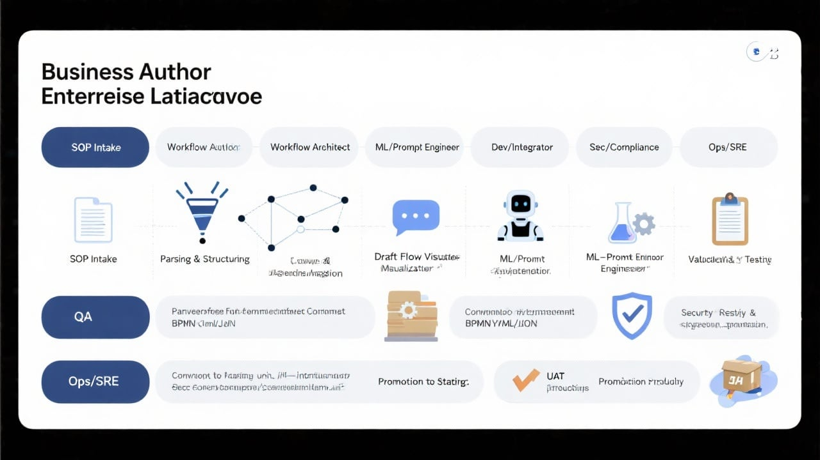
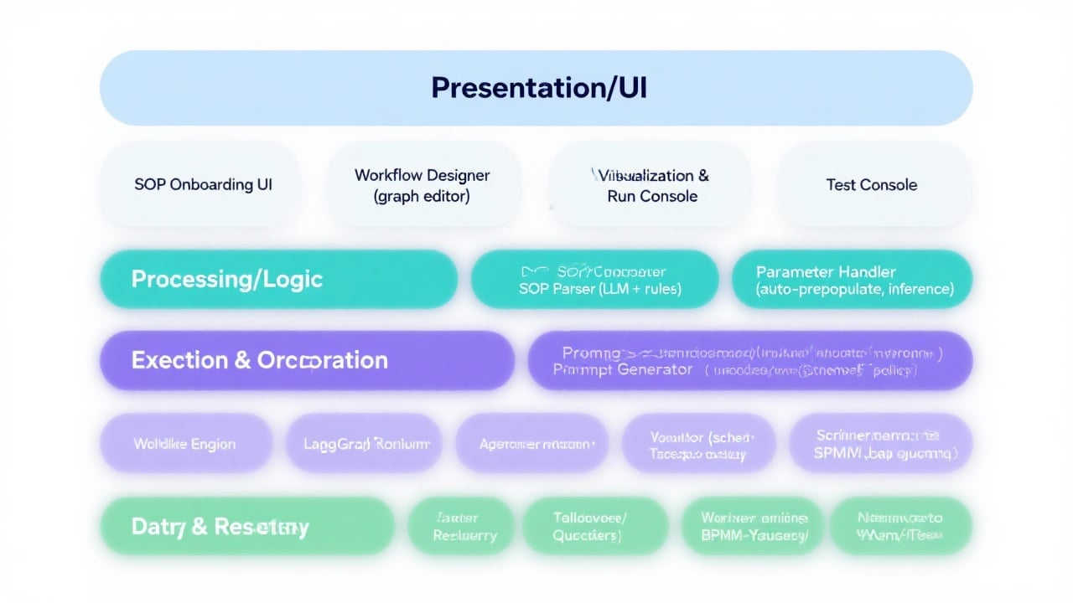
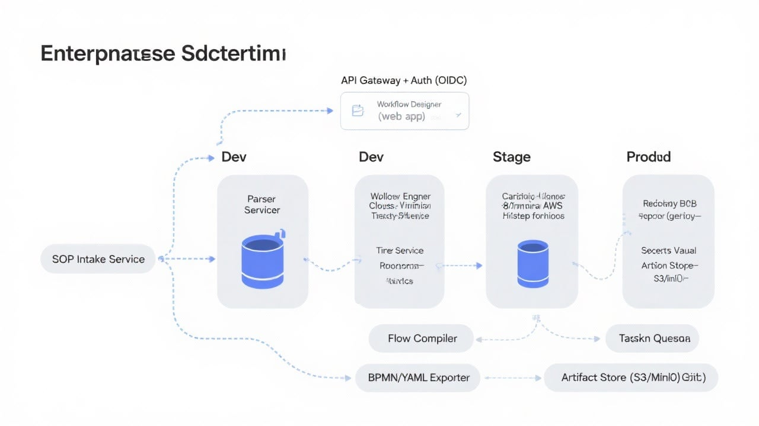
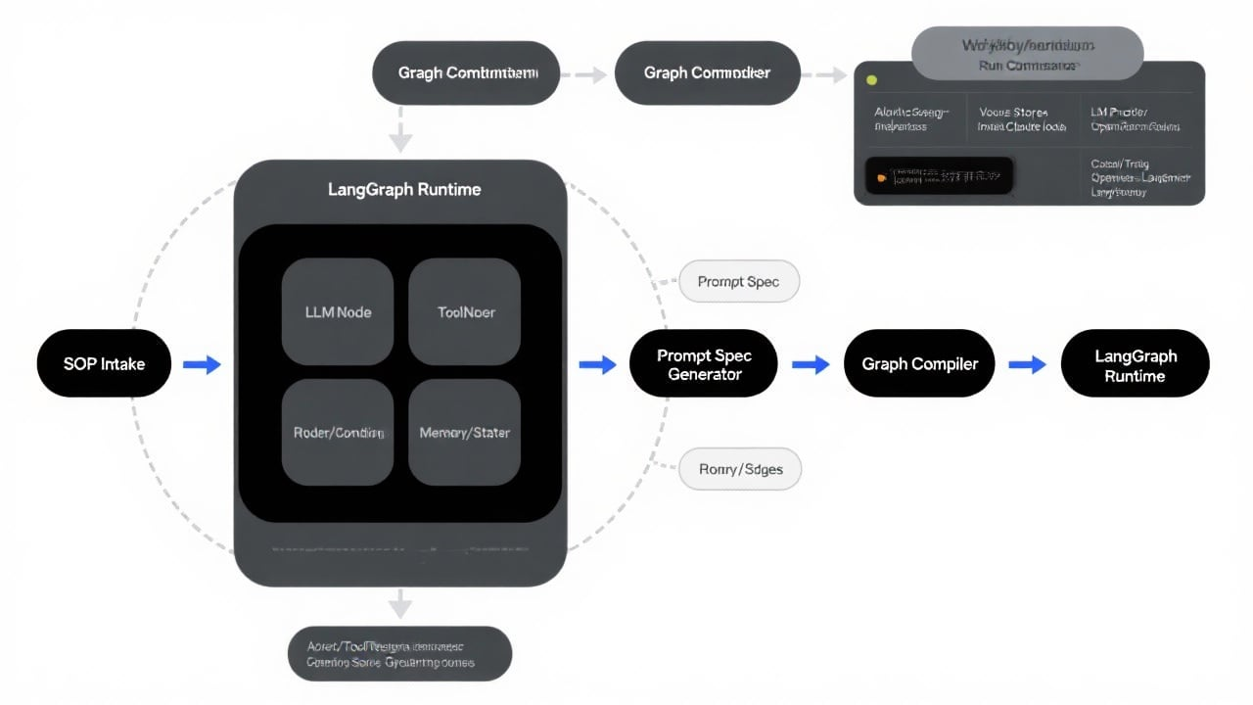
Thought for 16 seconds
**Preparing the document**
I need to draft the document and include the images, which I've seen before. It's best to refer to them as "Lifecycle Diagram" and include the URLs. The instruction allows me to use previously generated image URLs, which can be helpful. The UI already shows the images, so adding captions will work. I must follow default response instructions, which say to use markdown with appropriate headings and provide tables. I’ll create comparison tables for Buy vs Build options and different components without including any code.
**Structuring the document**
I’m planning to include rows for components like the SOP parser, visualization, workflow execution, and others. While the minimal requirement includes seven components, I’ll add primary ones for a more comprehensive overview.
I need to compare "traditional Workflow Engines" with LangGraph in the technology choices table. Options for "Workflow Execution" will include various engines like Camunda 8 and Airflow, plus a section discussing pros and cons. I'll detail strengths and trade-offs for each engine, along with a separate section on LangGraph's implementation path, covering dynamic routing and other integrations.
**Outlining sections of the document**
I’m planning to have Section 6 focus on "Comparison," featuring a table that spans different axes. In Section 7, titled "Sample Outputs," I'll reference the images above, including the "technology decision matrix table."
I need to craft the content without asking clarifying questions—so I'll structure the "Lifecycle Flow Documentation" listing steps, activities, and more. Additionally, I’ll cover key events, versioning semantics, data model glimpses, observability, and security concerns. I need to keep everything concise, but it’s shaping up to be a substantial document.
**Referencing images correctly**
I need to reference the images I've created and consider including their URLs using Markdown for clarity. However, the instructions state that images are already displayed in the chat interface, which means I shouldn't try to embed them again. Instead, captions like "See Lifecycle Diagram (Image 1)" will work well. While linking to the URLs can be helpful, I’ll play it safe and avoid including them since the images are already viewable, allowing users to download them if necessary.
**Crafting the content**
I'm planning to start by including "Image 1: End-to-end lifecycle flow (16:9)" in the document. The "Technology Choices Table" will also be quite extensive, featuring columns for Component, Build Approach (stack), Buy/Open Source Options, Recommendation, and Rationale. It might be wide, but Markdown can handle that!
Additionally, there will be a comparison table contrasting "Engine vs. LangGraph" with appropriate axes. I’ll also cover "Testing and Validation" strategies. Now I’ll focus on crafting the content based on this structure.
### IDE-like Workflow Development Platform — Technical Architecture Blueprint
This document is a reference architecture for an IDE-like Workflow Development Platform that ingests SOPs, converts them into structured workflows, generates LLM prompts and agent mappings, enables interactive visualization and configuration, converts flows into execution formats, validates in lower environments, and promotes to production with versioning and rollback. It provides lifecycle coverage, layered architecture, technology choices, and two implementation paths: Workflow Engine–based and LangGraph-based (agentic) — with diagrams and decision matrices.
Note: The following diagrams have been generated and displayed in this chat.
- Image 1: End-to-End Workflow Lifecycle Diagram (16:9)
- Image 2: Layered Architecture Blueprint (16:9)
- Image 3: System Architecture — Workflow Engine Path (16:9)
- Image 4: System Architecture — LangGraph Path (16:9)
---
### 1) End-to-End Workflow Management Lifecycle
#### 1.1 Lifecycle
stages (SOP → Production) and artifacts
- Stage 0: SOP Intake
- Inputs: SOP documents (PDF, DOCX, wiki), policies, reference data.
- Activities: Upload, classify SOP type, metadata capture (domain, risk level, PII flags).
- Outputs: SOP record, raw artifact, hashes, data sensitivity tags.
- Owner(s): Business Author, Architect.
- Stage 1: Parsing & Structuring
- Activities: LLM-assisted chunking, section labeling, step and decision extraction; rules-based normalizers; glossary/term linking.
- Outputs: Parsed Flow JSON (canonical model), glossary links, unresolved variables list.
- Gates: Parsing quality threshold, human validation for critical SOPs.
- Owner(s): Workflow Architect.
- Stage 2: Draft Flow Visualization
- Activities: Auto-layout of nodes/edges; annotation of actors, systems, SLAs; add human tasks vs automated tasks.
- Outputs: Visual Graph (draft), unresolved nodes flagged, comments.
- Owner(s): Architect, Dev/Integrator.
- Stage 3: Prompt & Agent/Service Mapping
-
Activities: Prompt template generation by node; mapping to agents/tools/services; tool schema definitions; RAG sources.
- Outputs: Prompt Spec (per node/class), Agent Registry Map (tools, connectors), policy guardrails.
- Owner(s): ML/Prompt Engineer.
- Stage 4: Parameter Inference & Configuration
- Activities: Pre-populate defaults via inference; parameter binding (env vars, secrets, feature flags); data contracts.
- Outputs: Parameter set with provenance, validation rules, test data stubs.
- Owner(s): Architect, Dev/Integrator.
- Stage 5: Conversion to Execution Format
- Activities: Compile to BPMN, YAML/JSON (Temporal/Step Functions/Airflow specs), LangGraph graph schema.
- Outputs: Execution Spec(s) + artifact bundle; schema checks.
- Owner(s): Dev/Integrator.
- Stage 6: Validation & Testing (lower env)
- Activities: Linting/schema validation; local simulation (dry-run); unit tests for nodes; integration tests with mocks/stubs; golden prompt evaluation; security scans.
- Outputs:
Test report, quality gates pass/fail, signed release candidate.
- Owner(s): QA, Security.
- Stage 7: Approval & Promotion (Staging, UAT, Production)
- Activities: Change review, approvals; staged deployment; UAT; production promotion; feature-flag gating.
- Outputs: Deployed versioned workflow; migration records.
- Owner(s): Sec/Compliance, Ops/SRE.
- Stage 8: Monitoring, Feedback, Versioning & Rollback
- Activities: Trace/metric/log collection; cost and drift monitoring; feedback loop to backlog; hotfix/rollback using immutable versions.
- Outputs: Operational dashboards, evaluation metrics, changelogs.
- Owner(s): Ops/SRE, Architect.
Artifacts across lifecycle:
- SOP Document → Parsed Flow JSON → Visual Graph → Prompt Spec → Agent Registry Map → Parameter Set → Execution Spec (BPMN/YAML/JSON/Graph) → Test Artifacts → Release Package → Runtime Metrics/Traces.
Image 1 shows the lifecycle stages across swimlanes for Business Author, Workflow Architect, ML/Prompt Engineer, Dev/Integrator, QA,
Sec/Compliance, Ops/SRE, with stage gates and bidirectional feedback loops between Testing ↔ Config and Monitoring ↔ Backlog.
#### 1.2 Environments and promotion
- Environments: Dev → Stage → Prod (physically isolated where possible).
- Promotion:
- Immutable artifacts (tagged by version).
- Signed manifests and provenance (SLSA-like attestations).
- Controlled configuration drift (env overlays).
- Rollback:
- Declarative rollback to the last good version (config and artifacts).
- Blue/green or canary deployment strategies tied to feature flags for risk reduction.
---
### 2) Layered System Architecture
Image 2 depicts the layered architecture with inter-layer interfaces and external integrations.
#### 2.1 Layers and components
- Presentation/UI Layer
- SOP Onboarding UI (upload, classify, metadata capture)
- Workflow Designer (graph editor, node palette, property panel)
- Visualization & Run Console (simulate, step-through)
- Test Console (golden prompts, mock/stub orchestration, diff
view)
- Processing/Logic Layer
- SOP Parser (LLM + rules; glossary mapping; policy enforcement)
- Prompt Generator (templates, guardrails, grounding context)
- Parameter Handler (auto-prepopulate; schema-based; env overlays)
- Validator (schema, policy, security, PII checks)
- Converter (BPMN/YAML/JSON/LangGraph compilation)
- Execution & Orchestration Layer
- Workflow Engine (Camunda/Temporal/Step Functions/Airflow)
- LangGraph Runtime (agentic graph execution)
- Agent Framework (tools/executors, rate limiting, retries)
- Task Workers (connectors: HTTP, DB, SaaS)
- Scheduler/Job Queue (async orchestration, retries, dead-lettering)
- Data & Registry Layer
- Workflow Registry (metadata, lineage, ownership, tags)
- Parameter DB (key–value config with scoping/versioning)
- Secrets Vault (KMS-backed)
- Versioning Repository (Git-based)
- Artifact Store (S3/MinIO)
- Vector Store (embeddings for RAG)
- Feature Flag Store (env toggle control)
- Integration & Security Layer
-
API Gateway (routing, throttling, WAF)
- AuthN/OIDC (SSO: Okta/Auth0/Cognito)
- RBAC/ABAC (tenant, project, role policies)
- Audit & Compliance (immutable logs)
- Environment Manager (dev/stage/prod isolation, config overlays)
- Observability (OpenTelemetry, Jaeger, Prometheus/Grafana)
- Event Bus/Message Queue (Kafka/NATS/SQS)
#### 2.2 Deployment topology (reference)
- Multi-tenant SaaS or single-tenant deployment.
- Stateless services (Parser, Generator, Converter, API) horizontally scaled behind Gateway.
- Stateful components in managed services where possible (Postgres, S3, Vector DB).
- Separate runtime clusters for Workflow Engine and LangGraph to allow either-or or hybrid selection per flow.
---
### 3) Technology Decision Tables
#### 3.1 Buy vs Build recommendations
| Component | Build Approach (if Build) | Buy/Open Source Options | Recommendation | Rationale |
|---|---|---|---|---|
| SOP Parser | LLM-driven parsing with prompt chains + rule-based post-processing; spaCy for NER;
custom schemas | OpenAI/Claude APIs, Azure OpenAI; GCP DocAI; Amazon Textract; Unstructured.io | Hybrid: Start with build on LLM APIs + Unstructured, add domain rules | Balances flexibility with speed; commercial OCR/structure extractors where needed |
| Visualization/Designer | React Flow/Dagre layout; custom property panel; schema-driven node forms | React Flow, D3, GoJS, AntV X6 | Buy/Adopt OSS primitives + build UX | OSS graph libs are mature; bespoke IDE experience is differentiator |
| Workflow Execution | Custom engine is high-risk; generate to engines | Camunda 8, Temporal, AWS Step Functions, Airflow/Prefect | Buy/Adopt OSS/managed engines | Engines are complex and mature elsewhere; invest in integration |
| LangGraph (Agentic) | Build graph compiler + runtime adapters | LangGraph, LangChain, Guidance, DSPy | Buy/Adopt OSS and extend | Rapidly evolving; focus on tooling and guardrails, not core runtime |
| Data Store (Registry) | Postgres with JSONB; S3 for artifacts; Redis for cache | Managed
Postgres (RDS/Cloud SQL), MinIO/S3, Redis | Buy/Managed | Operational burden reduction; durability and backups |
| AuthN/AuthZ | Policy engine + OIDC integrations | Auth0/Okta, AWS Cognito; OPA/OPAL for policy | Buy for AuthN; Build ABAC policies | SSO products mature; ABAC is domain-specific |
| Testing | Test harness SDKs; mock servers; golden prompt evaluator | Hoverfly/WireMock; Pact; Testkube; LangSmith evals | Hybrid | Combine off-the-shelf mock tools with custom LLM evals |
| Monitoring/Observability | OTel SDK; metrics/logs/traces export | OpenTelemetry, Jaeger, Prometheus, Grafana | Buy/Adopt OSS | Standardize on OTel; OSS stacks proven |
| Secrets | KMS + envelope encryption; policy checks | HashiCorp Vault, AWS Secrets Manager, GCP Secret Manager | Buy/Managed | Security-sensitive; use managed |
| Vector Store | Abstraction layer for providers | OpenSearch, pgvector, Pinecone, Weaviate, Milvus | Buy/Managed | Choose per latency/cost; keep adapter |
| Event Bus | Abstraction over streams/queues |
Kafka/MSK, NATS, SQS/SNS | Buy/Managed | Operationally heavy; managed preferred |
| CI/CD | Artifact sign, env overlays | GitHub Actions/GitLab CI, ArgoCD | Buy/Adopt | Common patterns; focus on policies |
#### 3.2 Traditional Workflow Engines vs LangGraph (summary)
- Traditional Engines (Camunda/Temporal/Step Functions/Airflow): Deterministic orchestration, strong state durability, timers, retries, human tasks (BPMN), compliance workflows, excellent for system integration and SLAs.
- LangGraph (Agentic): Dynamic reasoning, LLM-driven routing, tool use, iterative planning; best for knowledge work automation, unstructured inputs, adaptive flows.
A deeper comparison is in Section 6.
---
### 4) Workflow Engine Path (Camunda, Temporal, Airflow, Step Functions)
Image 3 shows the system architecture for this path.
#### 4.1 Architecture components
- Frontend (Workflow Designer/UI) via API Gateway + Auth (OIDC).
- SOP Intake → Parser → Flow Compiler → BPMN/YAML Exporter pipeline producing:
- BPMN for
Camunda; code-first workflows for Temporal; ASL JSON for Step Functions; DAGs for Airflow.
- Runtime:
- Engine Cluster per env (Dev/Stage/Prod).
- Workers/Activities implement tasks (HTTP, DB, SaaS).
- History/Visibility service, timers, retries, DLQs.
- Data:
- Registry DB (Postgres), Version Repo (Git), Artifact Store (S3/MinIO), Secrets (Vault).
- Tooling:
- CI/CD for promotion; Test Harness & Simulator; Observability (OTel, Jaeger, Prometheus/Grafana); Audit logs.
#### 4.2 Execution lifecycle
1) Author in Designer configures nodes → Compiler emits engine-specific artifacts.
2) CI pipeline validates, signs, stores artifacts.
3) Deployment to engine cluster via API; workers roll out in lockstep.
4) Tests execute with mocks/stubs; promotion gates enforce quality.
5) Production runs observed via traces/metrics/logs; change control manages rollbacks.
#### 4.3 Pros and cons
- Pros:
- Mature reliability (state, retries, timers).
- Strong compliance (BPMN human tasks, auditability).
-
Deterministic execution; good for SLAs and system integrations.
- Rich ops tooling in enterprise.
- Cons:
- Less dynamic/adaptive for unstructured tasks.
- Complex to model AI/LLM reasoning without custom nodes.
- Vendor/runtime coupling; cross-engine translation complexity.
- Human-in-the-loop UX may require add‑ons.
Use when:
- Regulated processes, clear control flows, strong SLAs, human tasks, system integration heavy workloads.
---
### 5) LangGraph Implementation Path (Agentic Workflows)
Image 4 shows the system architecture for this path.
#### 5.1 Architecture components
- SOP Intake → Parser → Prompt Spec Generator → Graph Compiler → LangGraph Runtime.
- Node types in runtime: LLMNode, ToolNode, Router/Conditional, Memory/State.
- Agent/Tool Registry: function schemas, throttling/quotas, safety policies.
- Vector Store for embeddings; LLM Providers (OpenAI/Claude/local).
- Callback/Tracing via OpenTelemetry/LangSmith; Evaluator & Test Harness (golden prompts, offline evals).
- Execution
Orchestrator (async job queue for runs).
- Security (OIDC, RBAC), Secrets Vault.
- Environments: Dev/Stage/Prod with promotion pipelines.
#### 5.2 Execution lifecycle
1) Parser extracts steps/decisions → Prompt Spec Generator creates structured prompt templates with guardrails and context bindings.
2) Graph Compiler maps prompts, tools, conditionals into a LangGraph graph (nodes/edges).
3) Runs execute within LangGraph runtime; state evolves with memory/context across nodes.
4) Observability captures token usage, latencies, tool calls, and decision paths.
5) Evaluator runs offline/online metrics (accuracy, cost, drift), gating promotions.
#### 5.3 Pros and cons
- Pros:
- High adaptability to unstructured inputs; dynamic routing.
- Natural fit for LLM tool use and reasoning loops.
- Rapid iteration on prompts and agent behaviors.
- Cons:
- Less deterministic; testability requires robust evaluation harnesses.
- Observability and cost management are more complex.
- Immature compared to traditional
engines for SLAs/human tasks.
- Versioning of prompts/tools requires strong governance.
Use when:
- Knowledge work automation, RAG/LLM-heavy flows, frequent evolution, exploratory decision-making.
---
### 6) Comparison: Workflow Engine vs LangGraph
| Axis | Workflow Engine (Camunda/Temporal/Step Functions/Airflow) | LangGraph (Agentic) |
|---|---|---|
| Scalability | Horizontal scaling with proven durability; Step Functions fully managed; Temporal high throughput | Scales well for async jobs; LLM calls can be bottlenecks; requires cost-aware throttling |
| Flexibility | Strong for deterministic control flows, timers, human tasks | Strong for adaptive flows, tool use, unstructured inputs |
| Developer Experience | BPMN modeling or code-first workflows; clear semantics | Graph + prompt engineering; higher iteration speed; needs eval harness |
| Observability | Mature (history, visibility, task metrics) | Improving; requires OTel + LLM-aware tracing; decision path introspection |
| Testing | Deterministic
unit/integration tests; local replay | Golden prompts, offline evals, simulation; less deterministic |
| Versioning | Strong artifact/version promotion; rollback well-understood | Prompt/version drift risk; must enforce immutability and governance |
| Extensibility | Plugin workers; enterprise connectors | Tool adapters; agent registries; rapid plugin development |
| Maturity | High in enterprise | Emerging, evolving rapidly |
| Best Fit | Regulated processes, SLAs, human-in-the-loop | Knowledge tasks, RAG, adaptive decisioning |
Recommendation:
- Default to Workflow Engine for compliance-heavy, deterministic business processes.
- Choose LangGraph where LLM reasoning and adaptability are central.
- Hybrid pattern: Use Workflow Engine as the outer orchestrator, invoking LangGraph subgraphs for AI-driven segments.
---
### 7) Sample Outputs
- Example visual workflow lifecycle diagram: Image 1 (End-to-End Lifecycle with roles, stages, gates).
- Example layering architecture diagram: Image 2 (5-layer
blueprint).
- Example system architecture diagram (Workflow Engine path): Image 3.
- Example system architecture diagram (LangGraph path): Image 4.
- Example technology decision matrix table: Section 3.1.
---
### 8) Cross-Cutting Architecture Details
#### 8.1 Canonical data model (conceptual)
- Flow: id, name, domain, risk level, owner, tags, currentVersion, lineage.
- Node: id, type (human, system, LLMNode, ToolNode, Router), inputs/outputs, policies, SLA.
- Edge: fromNode, toNode, condition, priority.
- PromptSpec: nodeId, template, variables, tools, guardrails, grounding sources.
- AgentMapping: nodeId, toolIds, provider, rate limits.
- Parameters: scoped (global/env/node), defaults, validators, provenance.
- ExecutionSpec: engineType, compiledArtifacts (BPMN/YAML/JSON/Graph), checksum.
- TestArtifacts: unit cases, integration mocks/stubs, golden prompts, expectations.
- Version: versionId, createdBy, changelog, approvals, artifactRefs, signatures.
#### 8.2 Security & compliance
- AuthN: OIDC SSO;
AuthZ: RBAC/ABAC policies; tenant isolation.
- Secrets in Vault/KMS; PII tagging from intake; data residency controls.
- Audit trails on all changes and executions; tamper-evident logs.
- Policy engine gates: data egress, LLM provider allowlist, prompt safety filters.
#### 8.3 Observability & cost
- OpenTelemetry traces for designer actions, compile steps, runtime executions.
- Metrics: success rate, latency percentiles, retries, cost per run (tokens/API calls).
- Logs: structured, redaction of sensitive data.
- Dashboards per flow/version/environment; anomaly detection and drift alerts.
#### 8.4 Testing & quality gates
- Schema linting on every change.
- Node unit tests (mocked dependencies).
- Flow integration with Hoverfly/WireMock stubs.
- Golden prompt evaluation with regression thresholds.
- Soak tests and chaos (timeouts, rate limits) for production readiness.
#### 8.5 Promotion, versioning, rollback
- Git-based versioning; semantic version tags; immutable artifact bundles in S3/MinIO with
checksums.
- Signed manifests; approvals workflow.
- Rollback: previous stable artifact set + config overlay; feature flags for gradual exposure.
---
### 9) Workflow Engine Path — Implementation Notes
- Camunda 8: BPMN-first, strong human task and decision modeling (DMN); Zeebe for execution; excellent visualization and ops.
- Temporal: Code-first workflows, strong durability, retries; good for microservice orchestration; visualization via web UI and custom dashboards.
- AWS Step Functions: Managed, pay-per-use; easy AWS integrations; service quotas; JSON ASL specs.
- Airflow/Prefect: Best for data/batch/ETL; not ideal for human tasks; can orchestrate ML pipelines.
Connector strategy:
- Workers as microservices (HTTP, DB, SaaS).
- Shared connector SDK with retry/circuit breaker patterns.
- Secrets injected at runtime via Vault.
---
### 10) LangGraph Path — Implementation Notes
- Graph compiler:
- Translates PromptSpec + AgentMapping → LangGraph nodes/edges with policies and memory/state
configuration.
- Support for routers/conditionals driven by LLM classification or deterministic rules.
- Runtime:
- Sandboxed tool execution, rate limiting, cost guards.
- Memory/state: ephemeral vs persisted (vector store, DB).
- Evaluator: offline test sets; online shadow runs; approval gates tied to metrics.
Provider abstraction:
- LLM provider adapters with retry/backoff, telemetry, redaction.
- Vector store adapters; schema for chunking/metadata.
---
### 11) Export/Conversion Formats
- BPMN 2.0 XML (Camunda 8); DMN for decisions.
- Temporal: code-gen scaffolds + workflow/activities YAML (definitions); worker contracts.
- AWS Step Functions: ASL JSON + Lambda/Service Integrations.
- Airflow/Prefect: DAG spec YAML + operator mappings.
- LangGraph: JSON/YAML graph schema describing nodes, edges, state, policies.
All exports include checksums, schema versions, and provenance metadata.
---
### 12) Governance & Operational Runbooks
- Change management: PR-based reviews, approver matrix,
evidence capture.
- Secrets rotation schedule; key management lifecycle.
- Incident response: runbooks per flow; rollback instructions; communication templates.
- Cost management: budgets, alerts, automated downgrades to cheaper providers where permitted.
---
This blueprint provides the lifecycle, layered architecture, technology options, and two implementation paths with visual diagrams to guide engineering and architecture teams building the IDE-like Workflow Development Platform.

